2/10/2025

Ahmed Essam

orange

Bank Customers EDA

With python

**Bank Customer Churn Analysis**

This analysis examines customer account information for 10,000 clients of a European bank, focusing on attributes such as credit score, balance, product usage, and churn status. The goal is to identify patterns in customer churn and explore key insights related to account behavior. Specifically, this study aims to answer the following questions:

1. What attributes are more common among churners compared to non-churners? Can customer churn be predicted based on the available data?
2. What are the overall demographic characteristics of the bank’s customers?
3. How do German, French, and Spanish customers differ in terms of account behavior?

By addressing these questions, the analysis seeks to provide data-driven insights that can help improve customer retention strategies.

* **Importing Libraries**
* We import the needed library
* **Loading and Preprocessing data**
* Before performing analysis, it is essential to preprocess the data to ensure accuracy and reliability. This step involves checking for missing values, handling inconsistencies, and preparing the data for further analysis.

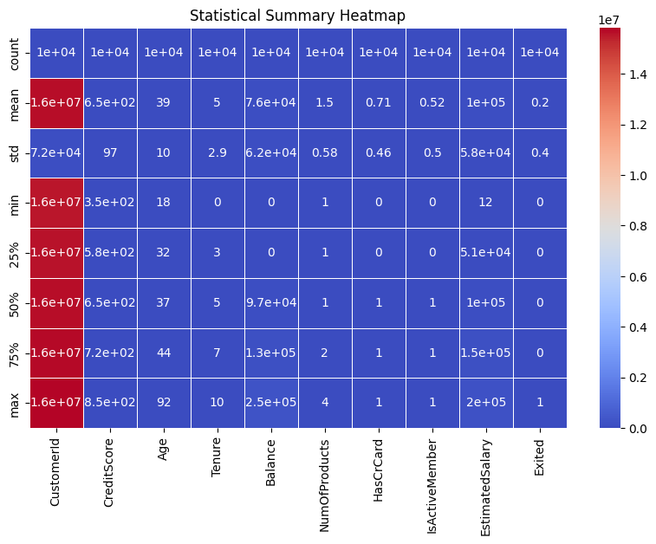

* **EDA**
* What attributes are more common among churners than non-churners? Can churn be predicted using the variables in the data?

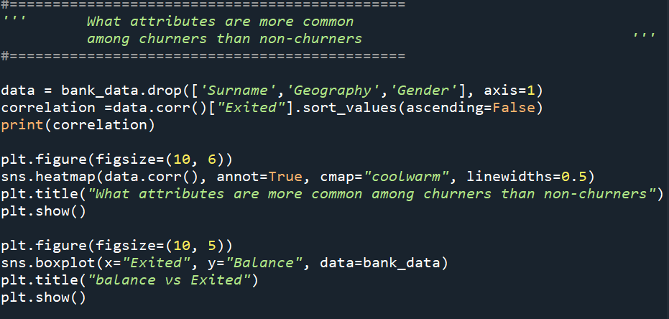

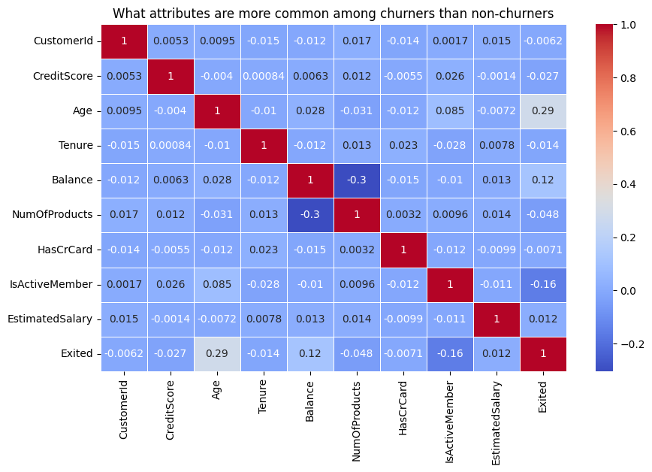

🎯 Recommendations based on these findings

✅ Reduce the churn of older customers

Offer special offers to older customers to retain them.

Provide financial advice tailored to them.

✅ Increase engagement of active and inactive customers

Offer rewards programs to active customers.

Send exclusive offers to inactive customers to encourage them to engage.

✅ Promote the use of more than one product

Encourage customers to subscribe to additional products such as loans or credit cards.

Offer discounts or privileges to those who own more than one product.

✅ Analyze the behavior of customers with high balances

Offer premium services to attract customers with high balances.

Design banking products tailored to them to maintain their loyalty.

1. **What do the overall demographics of the bank's customers look like?**

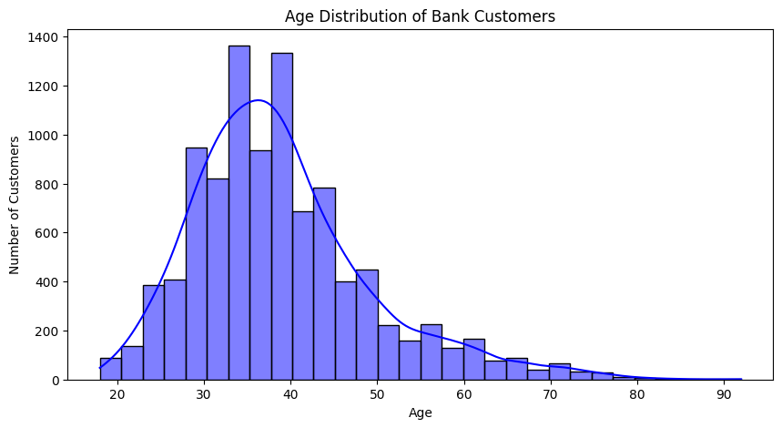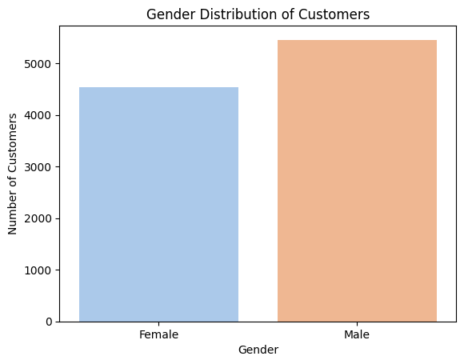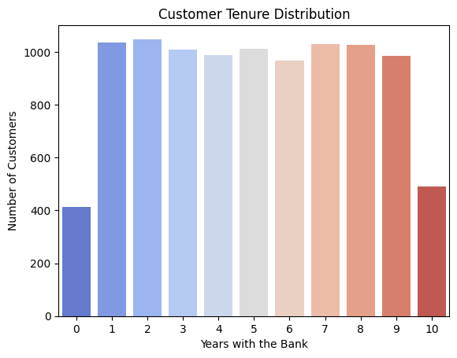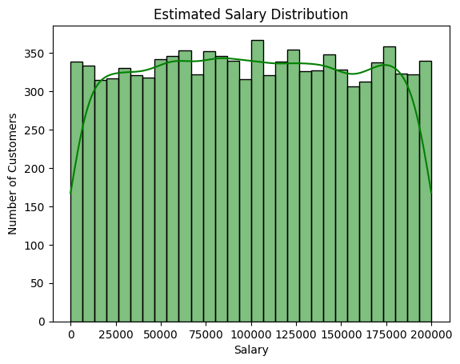I

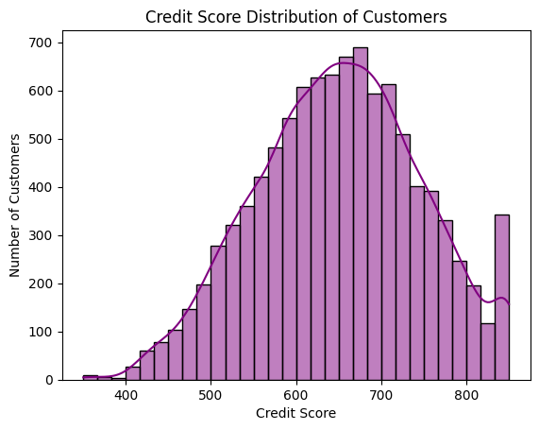

1. **Is there a difference between German, French, and Spanish customers in terms of account behavior?**

